





If you’re just getting started with writing case studies, look no further than this template. Included are section prompts to help you tell your customer’s complete story – from their background, to what led to them doing business with you, to the results they’ve seen.

As you work through this template, remember that it’s a starting off point for your customer story. You should add, delete, or edit any section headers that you see fit before sharing this case study on your website.

Note that the case study template is preceded by a planning outline to be completed by your team as well as a checklist before publishing. We’ve also included [Bracketed Prompts] for you to fill out the appropriate information in section headers, as well as italicized instructions to be erased before writing each section.

Outline: [Case Study Title]
Customer: [Enter Customer Name]
Company: [Enter Customer’s Company Name, If Applicable]
Industry: [Enter Customer’s Industry, If Applicable]
Buyer Persona: [Enter Targeted Reader and/or Buyer Persona]
Video: [Link to Video Case Study, If Applicable]
Author: [Enter Author Name]
Due Date: [Enter Due Date]
Publish Date: [Enter Desired Publish Date]

[Case Study Title]
Make sure the title runs for 70 characters or less.

Introduction
Lead into the post with a short introduction (approximately 100-words). Be sure to highlight:

- The customer’s name and a little bit about them.
- The opportunity the customer saw in your company.
- One or two key successes the customer had after working with your company.

The Story of [Customer Name]
In this section, provide a more in-depth overview on your customer. If it’s an individual, explain the person’s background in the context of your product/service. If it’s a business, talk about the company’s background, industry, and any recent successes or milestones they have had.

The [“Challenge” or “Opportunity”] of [Challenge/Opportunity the Customer Faced]
Explain the challenge or opportunity in front of the customer before they did business with you. This could be either a reactive reason (i.e. the customer had an issue that needed to be addressed) or a proactive reason (i.e. there was untapped potential that was unleashed by working with your business).

Why [Customer Name] Chose [Your Company Name]
In this section, speak about the decision process of your customer. Speak about how they discovered you, who else they considered, and what made them ultimately decide to do business with you.

How [Your Company Name] Responded
Here, explain what happened once your business started working with your customer. What was addressed first, and why? How did your customer feel about working with you in the early days?

The Results
In closing, speak to the results your customer saw after working with you. This section can be supported by statements, quotes, visuals, graphs, and metrics. Whatever you decide to include, be sure it illustrates how much of an impact your company made on your customer.

Call-to-Action
Use this section to encourage readers to get in touch with your sales team if they want to see the same results. Ideally, a link to the sales page, an embedded form for connecting with sales, and/or a phone number would be here.

Checklist Before Publishing
- Did you run the case study by your customer (and if applicable, your customer’s account manager) for approval?
- Does your case study clearly identify your customer’s need, your company’s process for addressing those needs, and the overall results?
- Are approved, compelling customer quotes woven throughout the case study?
- Are important success metrics that illustrate the impact of your product/service emphasized in the case study, occasionally with charts and/or graphs?
- Is there a clear call-to-action for interested readers to learn more about how to achieve similar results?
- Is the post 800-1,000 words at minimum?



If your customers have seen immense growth or data-backed success while working with you, this template is ideal. It’s structured to call out the most notable achievement metrics that a specific customer has seen with your product and/or service.

As you work through this template, remember that it’s a starting off point for your customer story. You should add, delete, or edit any section headers that you see fit before sharing this case study on your website. For example, we’ve allotted three dedicated sections for data points, but you should add more of these sections if there are more success points.

Note that the case study template is preceded by a planning outline to be completed by your team as well as a checklist before publishing. We’ve also included [Bracketed Prompts] for you to fill out the appropriate information in section headers, as well as italicized instructions to be erased before writing each section.

Outline: [Case Study Title]
Customer: [Enter Customer Name]
Company: [Enter Customer’s Company Name, If Applicable]
Industry: [Enter Customer’s Industry, If Applicable]
Buyer Persona: [Enter Targeted Reader and/or Buyer Persona]
Video: [Link to Video Case Study, If Applicable]
Author: [Enter Author Name]
Due Date: [Enter Due Date]
Publish Date: [Enter Desired Publish Date]

[Case Study Title]
Make sure the title runs for 70 characters or less and includes a compelling statistic.

Introduction
Lead into the post with a short introduction (approximately 100-words). Be sure to highlight:

- Multiple success metrics that the customer saw after doing business with you.
- The customer’s (company) name and a little bit about them.
- The opportunity the customer saw in your company.

The Story of [Customer Name]
In this section, provide a more in-depth overview on your customer. If it’s an individual, explain the person’s background in the context of your product/service. If it’s a business, talk about the company’s background, industry, and any recent successes in the news.

Also, briefly explain the challenges or opportunities the customer faced before they did business with you. This will make the improvement metrics you highlight have a greater impact on the reader.

Lastly, end this section by quickly explaining why the customer decided to do business with you to face these challenges/opportunities.

[Paragraph About Success Metric #1]
Explain the state of the customer before this specific success metric was attained, followed by an explanation of what your company did to achieve that metric. For example, if the success metric was “the company tripled its website traffic in three months,” explain the steps your business took to improve your client’s website performance, or the features of your product that were implemented to make that change happen.

If available, include at least one quote from your customer in this section, as well as a graph to help visualize the impact of your business, product, and/or service.

[Paragraph About Success Metric #2]
Explain the state of the customer before this specific success metric was attained, followed by an explanation of what your company did to achieve that metric. For example, if the success metric was “the company tripled its website traffic in three months,” explain the steps your business took to improve your client’s website performance, or the features of your product that were implemented to make that change happen.

If available, include at least one quote from your customer in this section, as well as a graph to help visualize the impact of your business, product, and/or service.

[Paragraph About Success Metric #3]
Explain the state of the customer before this specific success metric was attained, followed by an explanation of what your company did to achieve that metric. For example, if the success metric was “the company tripled its website traffic in three months,” explain the steps your business took to improve your client’s website performance, or the features of your product that were implemented to make that change happen.

If available, include at least one quote from your customer in this section, as well as a graph to help visualize the impact of your business, product, and/or service.

Overall Results
In closing, speak to the overall results your customer saw after working with you. This section can be supported by additional statements, quotes, visuals, graphs, and metrics. Whatever you decide to include, be sure it illustrates how much of an impact your company made on your customer.

Call-to-Action
Use this section to encourage readers to get in touch with your sales team if they want to see the same results. Ideally, a link to the sales page, an embedded form for a contact request, and/or a phone number would be included here.

Checklist Before Publishing
- Did you run the case study by your customer (and if applicable, your customer’s account manager) for approval?
- Do you lead with important success metrics that illustrate the impact of your product/service?
- Are these metrics emphasized throughout the case study and supported by charts and/or graphs?
- Does your case study clearly identify your customer’s need, your company’s process for addressing those needs, and the overall results?
- Are approved customer quotes woven throughout the case study?
- Is there a clear call-to-action for interested readers to learn more about how to achieve similar results?
- Is the post 800-1,000 words at minimum?



Hoping to use your case study to highlight one specific product or service that you sell? This case study is built for that. Its structure is similar to the general case study template, but you’ll be prompted to speak more so to the benefits of the specific product, rather than your team’s process for working with the customer.

As you work through this template, remember that it’s a starting off point for your customer story. You should add, delete, or edit any section headers that you see fit before sharing this case study on your website.

Note that the case study template is preceded by a planning outline to be completed by your team as well as a checklist before publishing. We’ve also included [Bracketed Prompts] for you to fill out the appropriate information in section headers, as well as italicized instructions to be erased before writing each section.

Outline: [Case Study Title]
Customer: [Enter Customer Name]
Company: [Enter Customer’s Company Name, If Applicable]
Industry: [Enter Customer’s Industry, If Applicable]
Buyer Persona: [Enter Targeted Reader and/or Buyer Persona]
Video: [Link to Video Case Study, If Applicable]
Customer: [Enter Product Name]
Author: [Enter Author Name]
Due Date: [Enter Due Date]
Publish Date: [Enter Desired Publish Date]

[Case Study Title]
Make sure the title runs for 70 characters or less and mentions the product.

Introduction
Lead into the post with a short introduction (approximately 100-words). Be sure to highlight:

- The customer’s name and a little bit about them.
- The opportunity the customer saw in your company.
- The product your case study is promoting as a helpful resource to your customer.

The Story of [Customer Name]
In this section, provide a more in-depth overview on your customer. If it’s an individual, explain the person’s background in the context of your product/service. If it’s a business, talk about the company’s background, industry, and any recent successes in the news.

Also, briefly explain the challenges or opportunities the customer faced before they did business with you. This will make the improvement metrics have a greater impact on the reader.

Lastly, end this section by quickly explaining why the customer decided to do business with you to face these challenges/opportunities.

The [“Challenge” or “Opportunity”] of [Challenge/Opportunity the Customer Faced] Before [Product Name]
Explain the challenge or opportunity in front of the customer before they started using the product. This could be either a reactive reason (i.e. the customer had an issue that needed to be addressed) or a proactive reason (i.e. there was untapped potential that was unleashed by working with your business).

Why [Customer Name] Chose [Product Name]
In this section, speak about the decision process of your customer. Speak about how they discovered the product, what other solutions else they considered, and what made them ultimately decide to select your product. Specific features of this product that help you stand out from competitors should be referenced here.

How [Customer Name] Used [Product]
In this section, talk about how the customer started using your product to better their lives and/or their business. This section should mention specific features unique to your product that made their success possible.

If available, include at least one quote from your customer in this section for their point of view.

The Results
In closing, speak to the results your customer saw after using your product. This section can be supported by statements, quotes, visuals, graphs, and metrics. Whatever you decide to include, be sure it illustrates how much of an impact your company made on your customer.

Call-to-Action
Use this section to highlight anything left unsaid about the product and to encourage readers to get in touch with your sales team if they want to see the same results. Ideally, a link to the product page and/or a phone number to sales would be here.

Checklist Before Publishing
- Did you run the case study by your customer (and if applicable, your customer’s account manager) for approval?
- Does your case study clearly identify your customer’s need, your product’s ability to address those needs, and the overall results of the business deal?
- Are approved customer quotes woven throughout the case study?
- Are important success metrics that illustrate the impact of your product/service emphasized in the case study, occasionally with charts and/or graphs?
- Is there a clear call-to-action for interested readers to learn more about how to achieve similar results with the product?
- Is the post 800-1,000 words at minimum?



[Case Study Title]
Make sure the title runs for 70 characters or less and mentions the product.

Introduction

Lead into the post with a short introduction (approximately 100-words). Be sure to highlight:

- Multiple success metrics that the customer saw after doing business with you.
- The customer’s (company) name and a little bit about them.
- The opportunity the customer saw in your company.

The Story of [Customer Name]  In this section, provide a more in-depth overview on your customer. If it’s an individual, explain the person’s background in the context of your product/service. If it’s a business, talk about the company’s background, industry, and any recent successes in the news.  Also, briefly explain the challenges or opportunities the customer faced before they did business with you. This will make the improvement metrics you highlight have a greater impact on the reader.  Lastly, end this section by quickly explaining why the customer decided to do business with you to face these challenges/opportunities. | 

The [“Challenge” or “Opportunity”] of [Challenge/Opportunity the Customer Faced] Before [Product Name] | Explain the challenge or opportunity in front of the customer before they started using the product. This could be either a reactive reason (i.e. the customer had an issue that needed to be addressed) or a proactive reason (i.e. there was untapped potential that was unleashed by working with your business).
Why [Customer Name] Chose [Product Name] | In this section, speak about the decision process of your customer. Speak about how they discovered the product, what other solutions else they considered, and what made them ultimately decide to select your product. Specific features of this product that help you stand out from competitors should be referenced here.
How [Customer Name] Used [Product] | In this section, talk about how the customer started using your product to better their lives and/or their business. This section should mention specific features unique to your product that made their success possible.  If available, include at least one quote from your customer in this section for their point of view.

The Results
In closing, speak to the results your customer saw after working with you. This section can be supported by statements, quotes, visuals, graphs, and metrics. Whatever you decide to include, be sure it illustrates how much of an impact your company made on your customer.

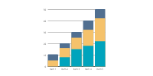 | 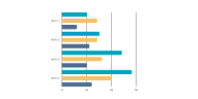

Call-to-Action
Use this section to encourage readers to get in touch with your sales team if they want to see the same results. Ideally, a link to the sales page, an embedded form for connecting with sales, and/or a phone number would be here.

 | [CTA Text]

Insert a one-sentence summary of the case study.

Introduction
Lead into the post with a short introduction (approximately 100-words). Be sure to highlight:

- The customer’s name and a little bit about them.
- The opportunity the customer saw in your company.
- One or two key successes the customer had after working with your company.
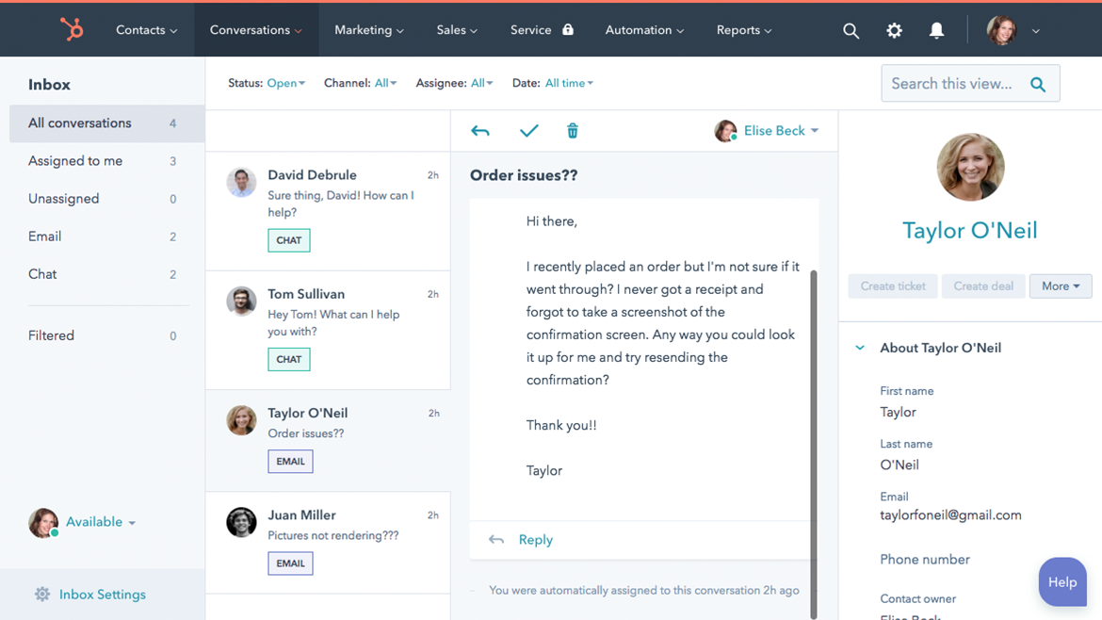
Replace the above image with an image of your product.
The Story of [Customer Name]
In this section, provide a more in-depth overview on your customer. If it’s an individual, explain the person’s background in the context of your product/service. If it’s a business, talk about the company’s background, industry, and any recent successes in the news.

Also, briefly explain the challenges or opportunities the customer faced before they did business with you. This will make the improvement metrics have a greater impact on the reader.

Lastly, end this section by quickly explaining why the customer decided to do business with you to face these challenges/opportunities.
The [“Challenge” or “Opportunity”] of [Challenge/Opportunity the Customer Faced] Before [Product Name]


Replace this image with a photo of your customer.

Explain the challenge or opportunity in front of the customer before they started using the product.

This could be either a reactive reason (i.e. the customer had an issue that needed to be addressed) or a proactive reason (i.e. there was untapped potential that was unleashed by working with your business).

Why [Customer Name] Chose [Product Name]
In this section, speak about the decision process of your customer.

Speak about how they discovered the product, what other solutions else they considered, and what made them ultimately decide to select your product.

Specific features of this product that help you stand out from competitors should be referenced here.

“Break up this section with an important quote from your customer about why they chose your product.”

The Results
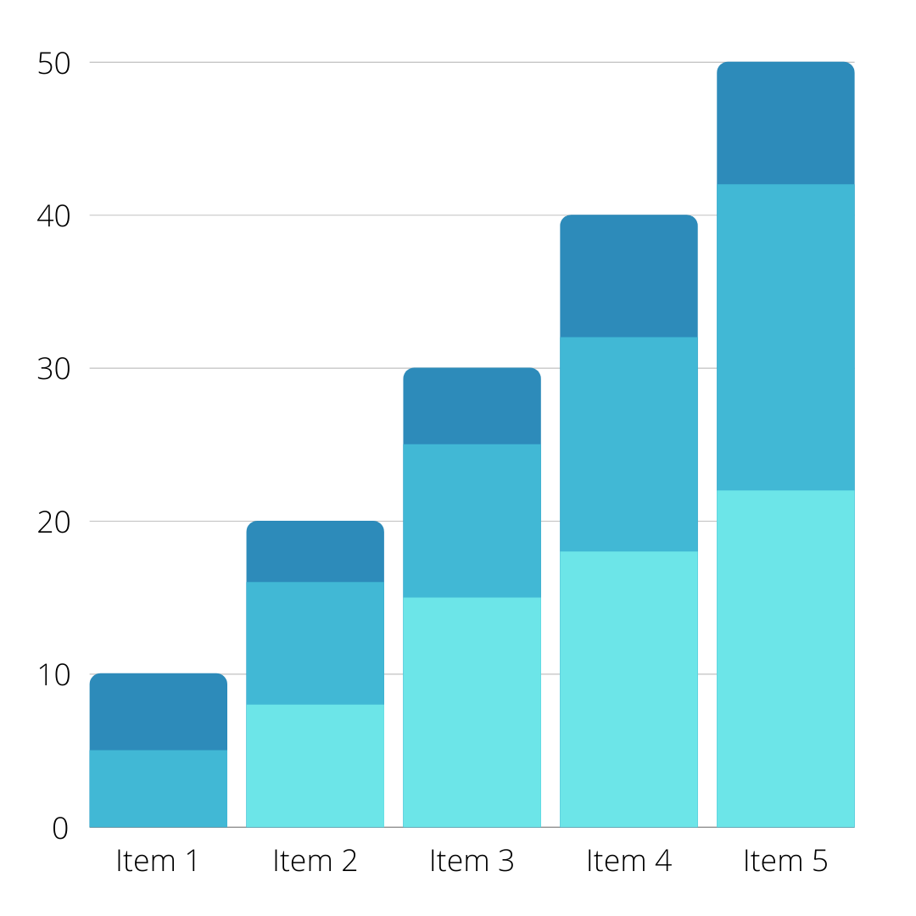
In closing, speak to the results your customer saw after using your product. This section can be supported by statements, quotes, visuals, graphs, and metrics. Whatever you decide to include, be sure it illustrates how much of an impact your company made on your customer.

Call-to-Action
Use this section to highlight anything left unsaid about the product and to encourage readers to get in touch with your sales team if they want to see the same results. Ideally, a link to the product page and/or a phone number to sales would be here.

[CTA Text]

[Case Study Title]
Make sure the title runs for 70 characters or less and mentions the product.

Introduction
Lead into the post with a short introduction (approximately 100-words). Be sure to highlight:

- Multiple success metrics that the customer saw after doing business with you.
- The customer’s (company) name and a little bit about them.
- The opportunity the customer saw in your company.

[Insert Success Metric #1] | [Insert Success Metric #1] | [Insert Success Metric #3]

The Story of [Customer Name]
In this section, provide a more in-depth overview on your customer. If it’s an individual, explain the person’s background in the context of your product/service.

If it’s a business, talk about the company’s background, industry, and any recent successes in the news.

Also, briefly explain the challenges or opportunities the customer faced before they did business with you. This will make the improvement metrics have a greater impact on the reader.

Lastly, end this section by quickly explaining why the customer decided to do business with you to face these challenges/opportunities.

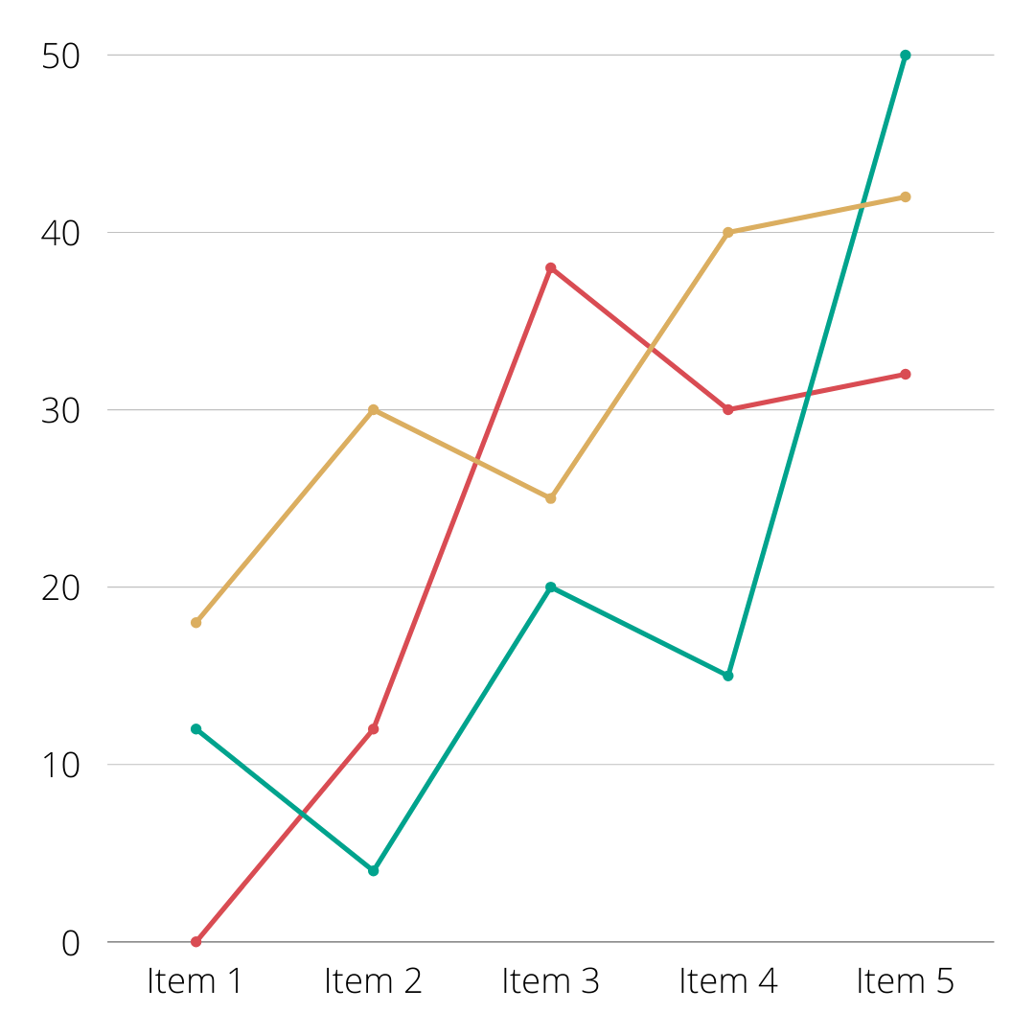 | [Paragraph About Success Metric #1]  Explain the state of the customer before this specific success metric was attained, followed by an explanation of what your company did to achieve that metric. For example, if the success metric was “the company tripled its website traffic in three months,” explain what you did to improve your client’s website performance, or the features of your product that were implemented to make that change happen.  If available, include at least one quote from your customer in this section, as well as a graph to help visualize the impact.
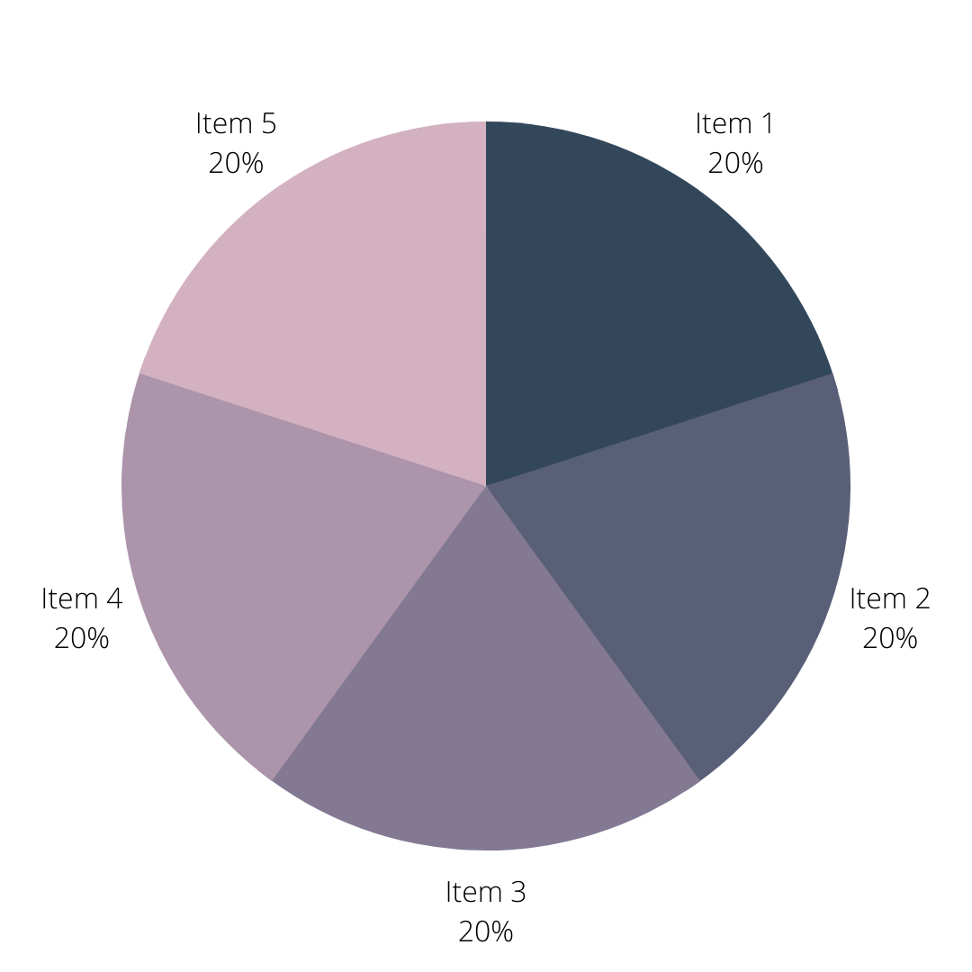 | [Paragraph About Success Metric #2]  Repeat the steps outlined above.
 | [Paragraph About Success Metric #3]  Repeat the steps outlined above.

Overall Results
In closing, speak to the overall results your customer saw after working with you. This section can be supported by additional statements, quotes, visuals, graphs, and metrics. Whatever you decide to include, be sure it illustrates how much of an impact your company made on your customer.

“Support the data in this case study with an impactful quote from your customer about your business.”

Call-to-Action
Use this section to encourage readers to get in touch with your sales team if they want to see the same results. Ideally, a link to the sales page, an embedded form for a contact request, and/or a phone number would be included here.

[CTA Text]

